Q1: **Write a shell script that takes a login name as command line argument and reports when that person logs in?.**

Q2: **Write a shell script that accepts two integers as its arguments and compute the value of first number raised to the power of the second number.**

Q3: Write a shell script that accepts a filename, starting and ending line numbers as arguments and displays all the lines between the given line numbers.

Q4: Write a shell script To Count number of files in a Directory. Ls | wc -l

Q5: Write a program to generate Fibonacci series.

Q6: Write a program to check whether given string is palindrome or not.

Q7: **Write a shell program for the following Scenario:**

**Enter any Job Title**

**1. Tutor**

**2. Lecturer**

**3. Associate Professor**

* First Condition is if job title is tutor (then check no of publication and years served, if years served greater than 5 and publication greater than 10,then promote the person as lecturer else more service and publication required).
* Second Condition is if job title is Lecturer (then check no of publication and years served, if years served greater than 12 and publication greater than 15,then promote the person as Associate professor else more service and publication required).
* Third Condition is if job title is Associate Professor (then check no of publication and years served, if years served greater than 15 and publication greater than 20,then promote the person as professor else more service and publication required).

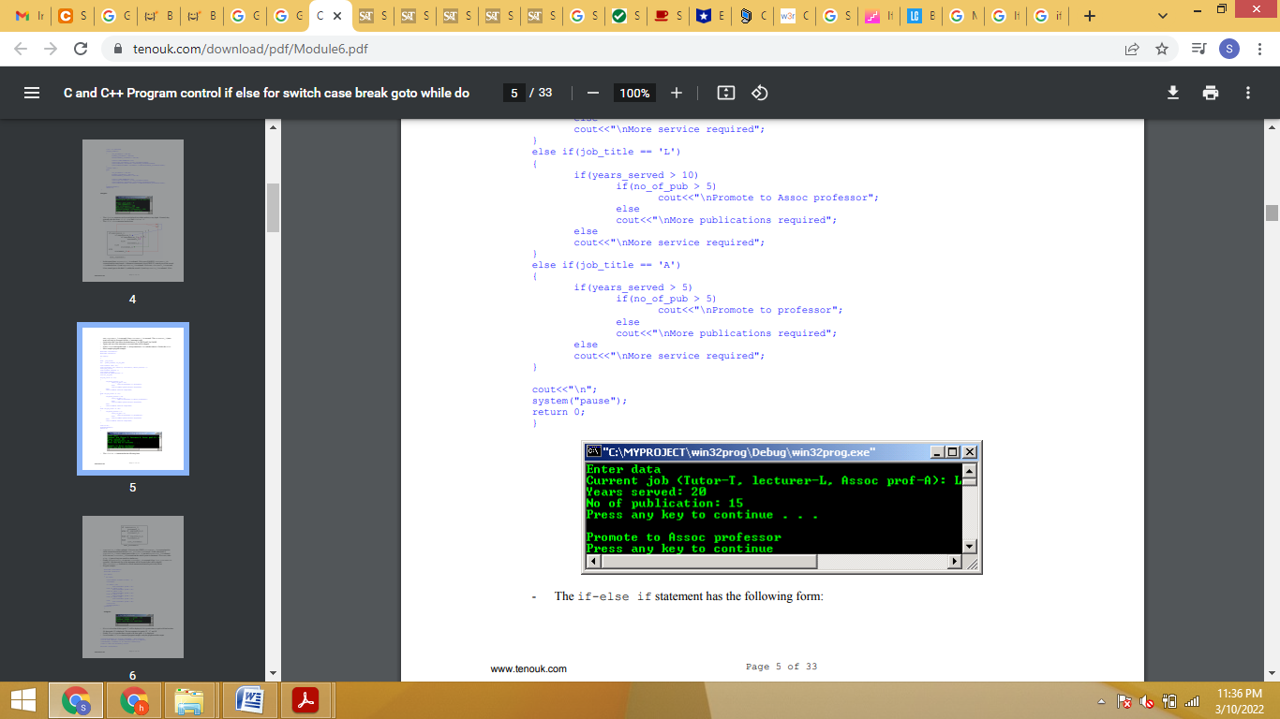

Q8: Write a shell script to Display the following pattern.

1 0

1 5

2 5

3 0

3 5

Q9: Write a shell script to Display CHESSBOARD patterns.

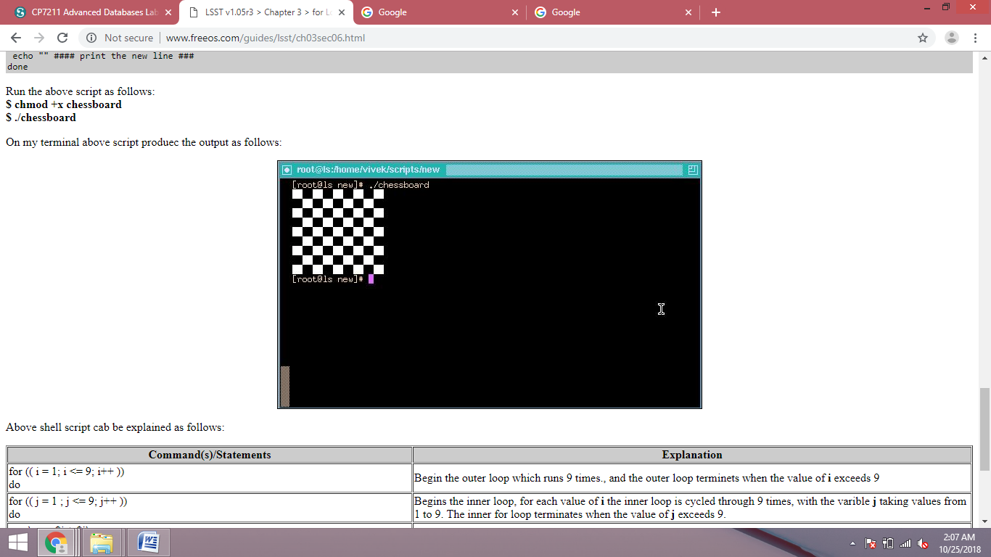

Q10: What is the difference between $* And $@?